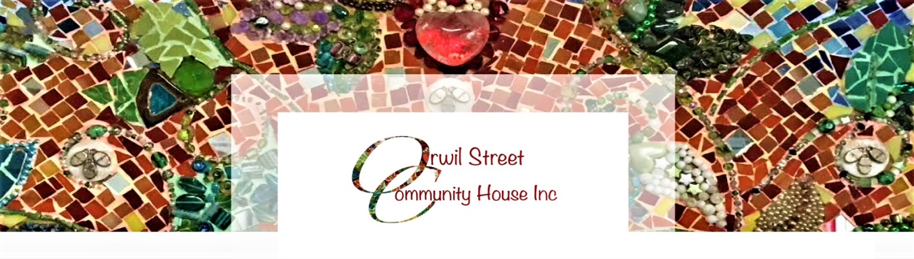
SANDRA GARNIER
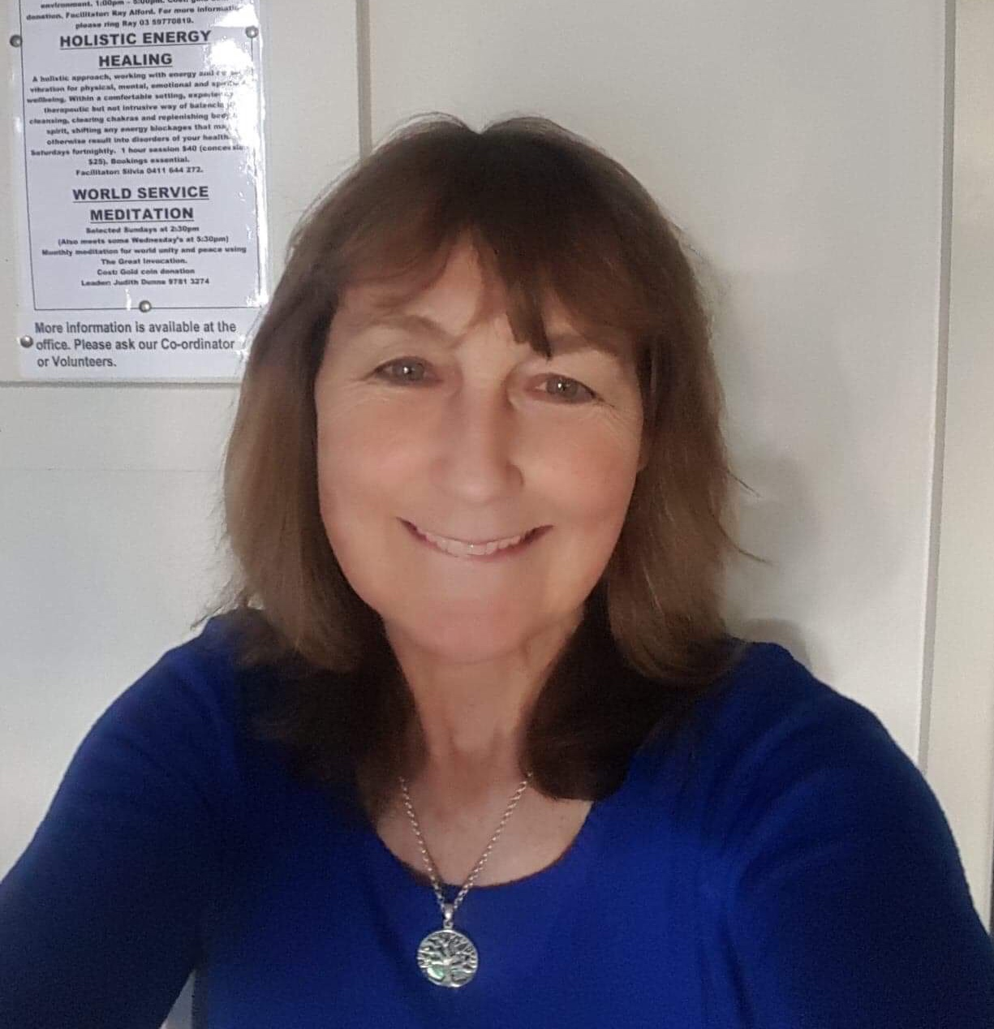
Sandra is a warm and approachable counsellor who believes in people and their ability to overcome life’s struggles to find a healthier and more peaceful way of living. She considers her counselling to be collaboration between herself and her clients, accompanying them as a ‘companion’ along their journey to wellbeing. Sandra specialises in anxiety/depression counselling as well as relationship counselling and spiritual direction. Sandra has completed 8 full time years post Year 12studywhich includes a Bachelor of Social Science (Pastoral Counselling), plus one a Diploma of Arts Therapy as well as a Graduated Diploma of Arts Therapy (total of 4 years of Art Therapy qualifications)and not only the 2 years a Diploma is made up of . Sandra has over ten years’ experience of being the Community Counsellor in Frankston North. Cost: $50.00 for the first visit and $40.00 for all following visits. We also offer Couples Counselling - Cost: $60.00 Please ring the House for bookings or more information

Please note** We do not wish people to be excluded because of financial pressure, so please, talk to our Coordinator (in complete confidence) if costs are a problem for you. **

Sandra also facilitates our RED Group (Women’s Support Group) on a Tuesday afternoon 1.00pm-3.00pm.

